1. **ASP .net program that demonstrate use of HTML Controls**

protected void Button1_Click(object sender, EventArgs e)

{

Label5.Text = TextBox1.Text;

Label6.Text = TextBox2.Text;

}

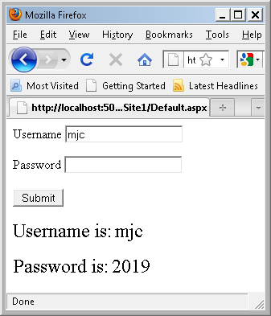

1. **ASP .net program that demonstrates use of web controls**

protected void Button1_Click(object sender, EventArgs e)

{

if (DropDownList1.SelectedValue == " ")

{

Label1.Text = "please select";

}

else

{

Label2.Text="your choice is "

+DropDownList1.SelectedValue;

}

}

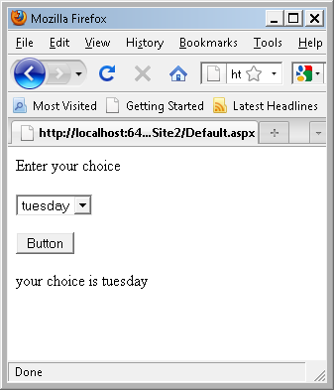

1. **ASP .net that returns the windows name of your computer**

public partial class _Default : System.Web.UI.Page

{

protected void Page_Load(object sender, EventArgs e)

{

Response.Write("your IP Address:" + Request.UserHostAddress + "<br>");

Response.Write("your Computer name:" + System.Net.Dns.GetHostEntry(Request.UserHostAddress).HostName);

}

}

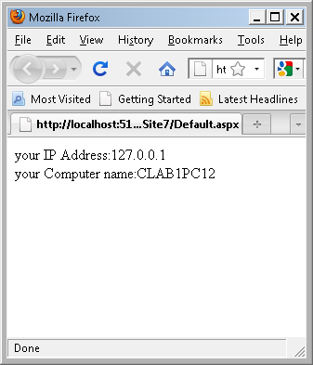

1. **ASP .net program that demonstrates use of Validations Controls**

public partial class _Default : System.Web.UI.Page

{

protected void Page_Load(object sender, EventArgs e)

{

}

protected void Button1_Click(object sender, EventArgs e)

{

Label1.Text = TextBox1.Text;

}

}

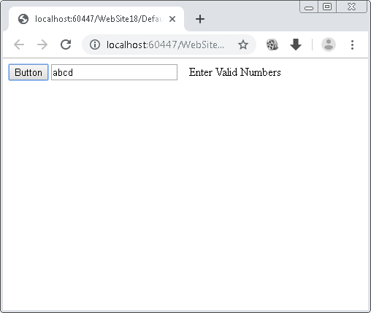 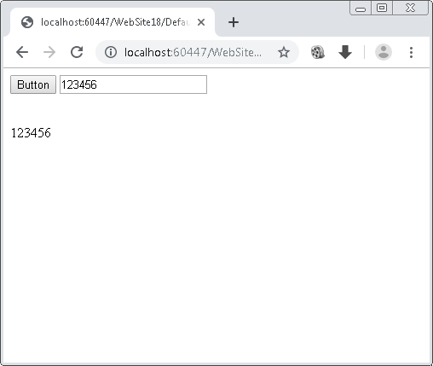

**5. ASP .net program that demonstrates use of Intrinsic Objects.**

public partial class _Default : System.Web.UI.Page

{

protected void Page_Load(object sender, EventArgs e)

{

}

protected void Button1_Click(object sender, EventArgs e)

{

if (!String.IsNullOrEmpty(TextBox1.Text))

{

Label1.Text = "welcome " + Server.HtmlEncode(TextBox1.Text) + ".<br/> The URL is" + Server.UrlEncode(Request.Url.ToString());

}

}

}

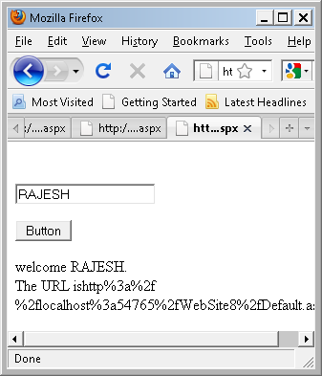

**6. ASP .net program that demonstrate Application and Session Scope Variables using Global.Asax**

**Global.aspx**

<script runat="server">

public static int count=0;

void Application_Start(object sender, EventArgs e)

{

Application["my count"] = count;

}

void Session_Start(object sender, EventArgs e)

{

count=Convert.ToInt32( Application["my count"]);Application["my count"]=count+1;

}

</script>

**Default.aspx**

public partial class _Default : System.Web.UI.Page

{

protected void Page_Load(object sender, EventArgs e)

{

int a;

a = Convert.ToInt32((Application["my count"]));

Label1.Text = Convert.ToString(a);

if (a < 10)

Label1.Text = "000" + Label1.Text;

else if(a<100)

Label1.Text = "00" + Label1.Text;

else if(a<1000)

Label1.Text = "0" + Label1.Text;

}

}

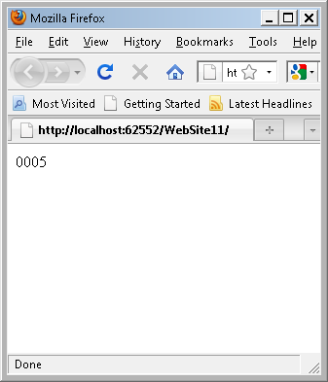

**7. ASP .net program Demonstrate use of Master Page**

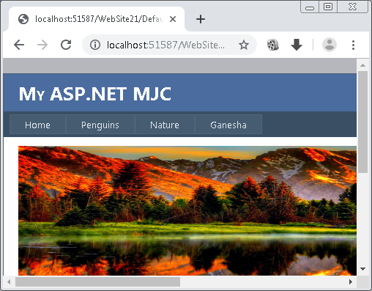

**8. ASP .net page that used the connection object to connect the database and display information using datagrid Controls.**

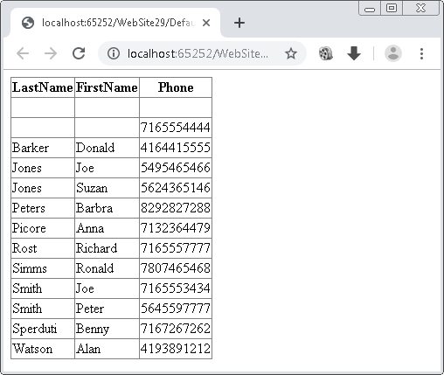

**9. Website navigation controls (sitemap path, treeview, menu) using SiteMap file**

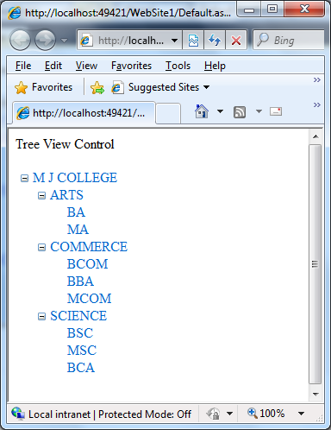 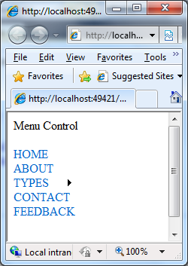

**10. ASP.NET objects (HTTPApplicationState, HTTPSessionState)**

**<WEB FORM>**

public partial class _Default : System.Web.UI.Page

{

protected void Page_Load(object sender, EventArgs e)

{

Response.Write("the number of users online :" + Application["user"].ToString());

}

}

**<GLOBAL PAGE>**

<script runat="server">

void Application_Start(object sender, EventArgs e)

{

// Code that runs on application startup

Application["user"] = 0;

}

void Session_Start(object sender, EventArgs e)

{

// Code that runs when a new session is started

Application.Lock();

Application["user"] = (int)Application["user"] + 1;

Application.UnLock();

}

void Session_End(object sender, EventArgs e)

{

// Code that runs when a session ends.

// Note: The Session_End event is raised only when the sessionstate mode

// is set to InProc in the Web.config file. If session mode is set to StateServer

// or SQLServer, the event is not raised.

Application.Lock();

Application["user"] = (int)Application["user"] -1;

Application.UnLock();

}

</script>

